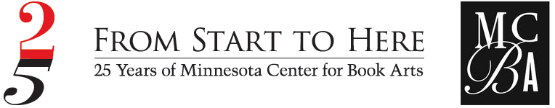
HAPPY BOOK ARTS ANNIVERSARY!
Visit us Saturday, June 26 to help us celebrate
Minnesota Center for Book Arts 25th anniversary.

Join us for a Community Open House. Bring a friend, bring family or come solo and enjoy artist demonstrations, make-and-take activities, a special exhibition in the gallery space and more!

Who: Everyone
What: 25th Anniversary Community Open House
Where: Minnesota Center for Book Arts (MCBA)
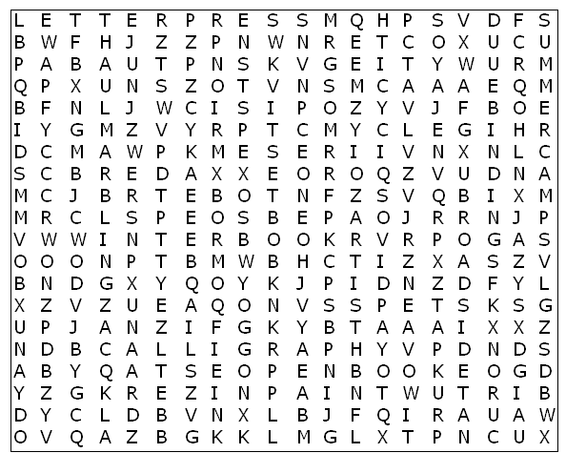
When: Saturday, June 26. 10 am – 4 pm!
How: Free and Fun for all.

WORD FIND - DEAL ALERT
Complete this book arts word find and bring it to the 25th Anniversary open house and you may win a $100 MCBA Gift Certificate.

artist comics mcba screen printing

binding design open book stamping

book ink paint story

broadside letterpress paper summer camps

calligraphy marbling poster winter book

Your Name: ________________________________________

Your Email Address: __________________________________

You like: ______________________________ best about MCBA.

